Far East Geological Institute
Far East Branch
Russian Academy of Sciences
Prospect 100-letya, 159,
Vladivostok-22
690022 RUSSIA

Tel. (423) 2-318–750 Fax (423) 2–317–847 http://www.fegi.ru/
E-mail: fegi@vlad.ru; office@fegi.ru

Outgoing № 01-07/1548
Gemmological laboratory Tel. (4232) 31 – 76 - 04
1st of July 2015

Expertise of 6 beads with total weight of 24.40 grams and one sample of tumbled amber weighing 6.03 grams, provided by Baltic Technologies Vladivostok Company

Pictures of the samples from № 1 to № 7:
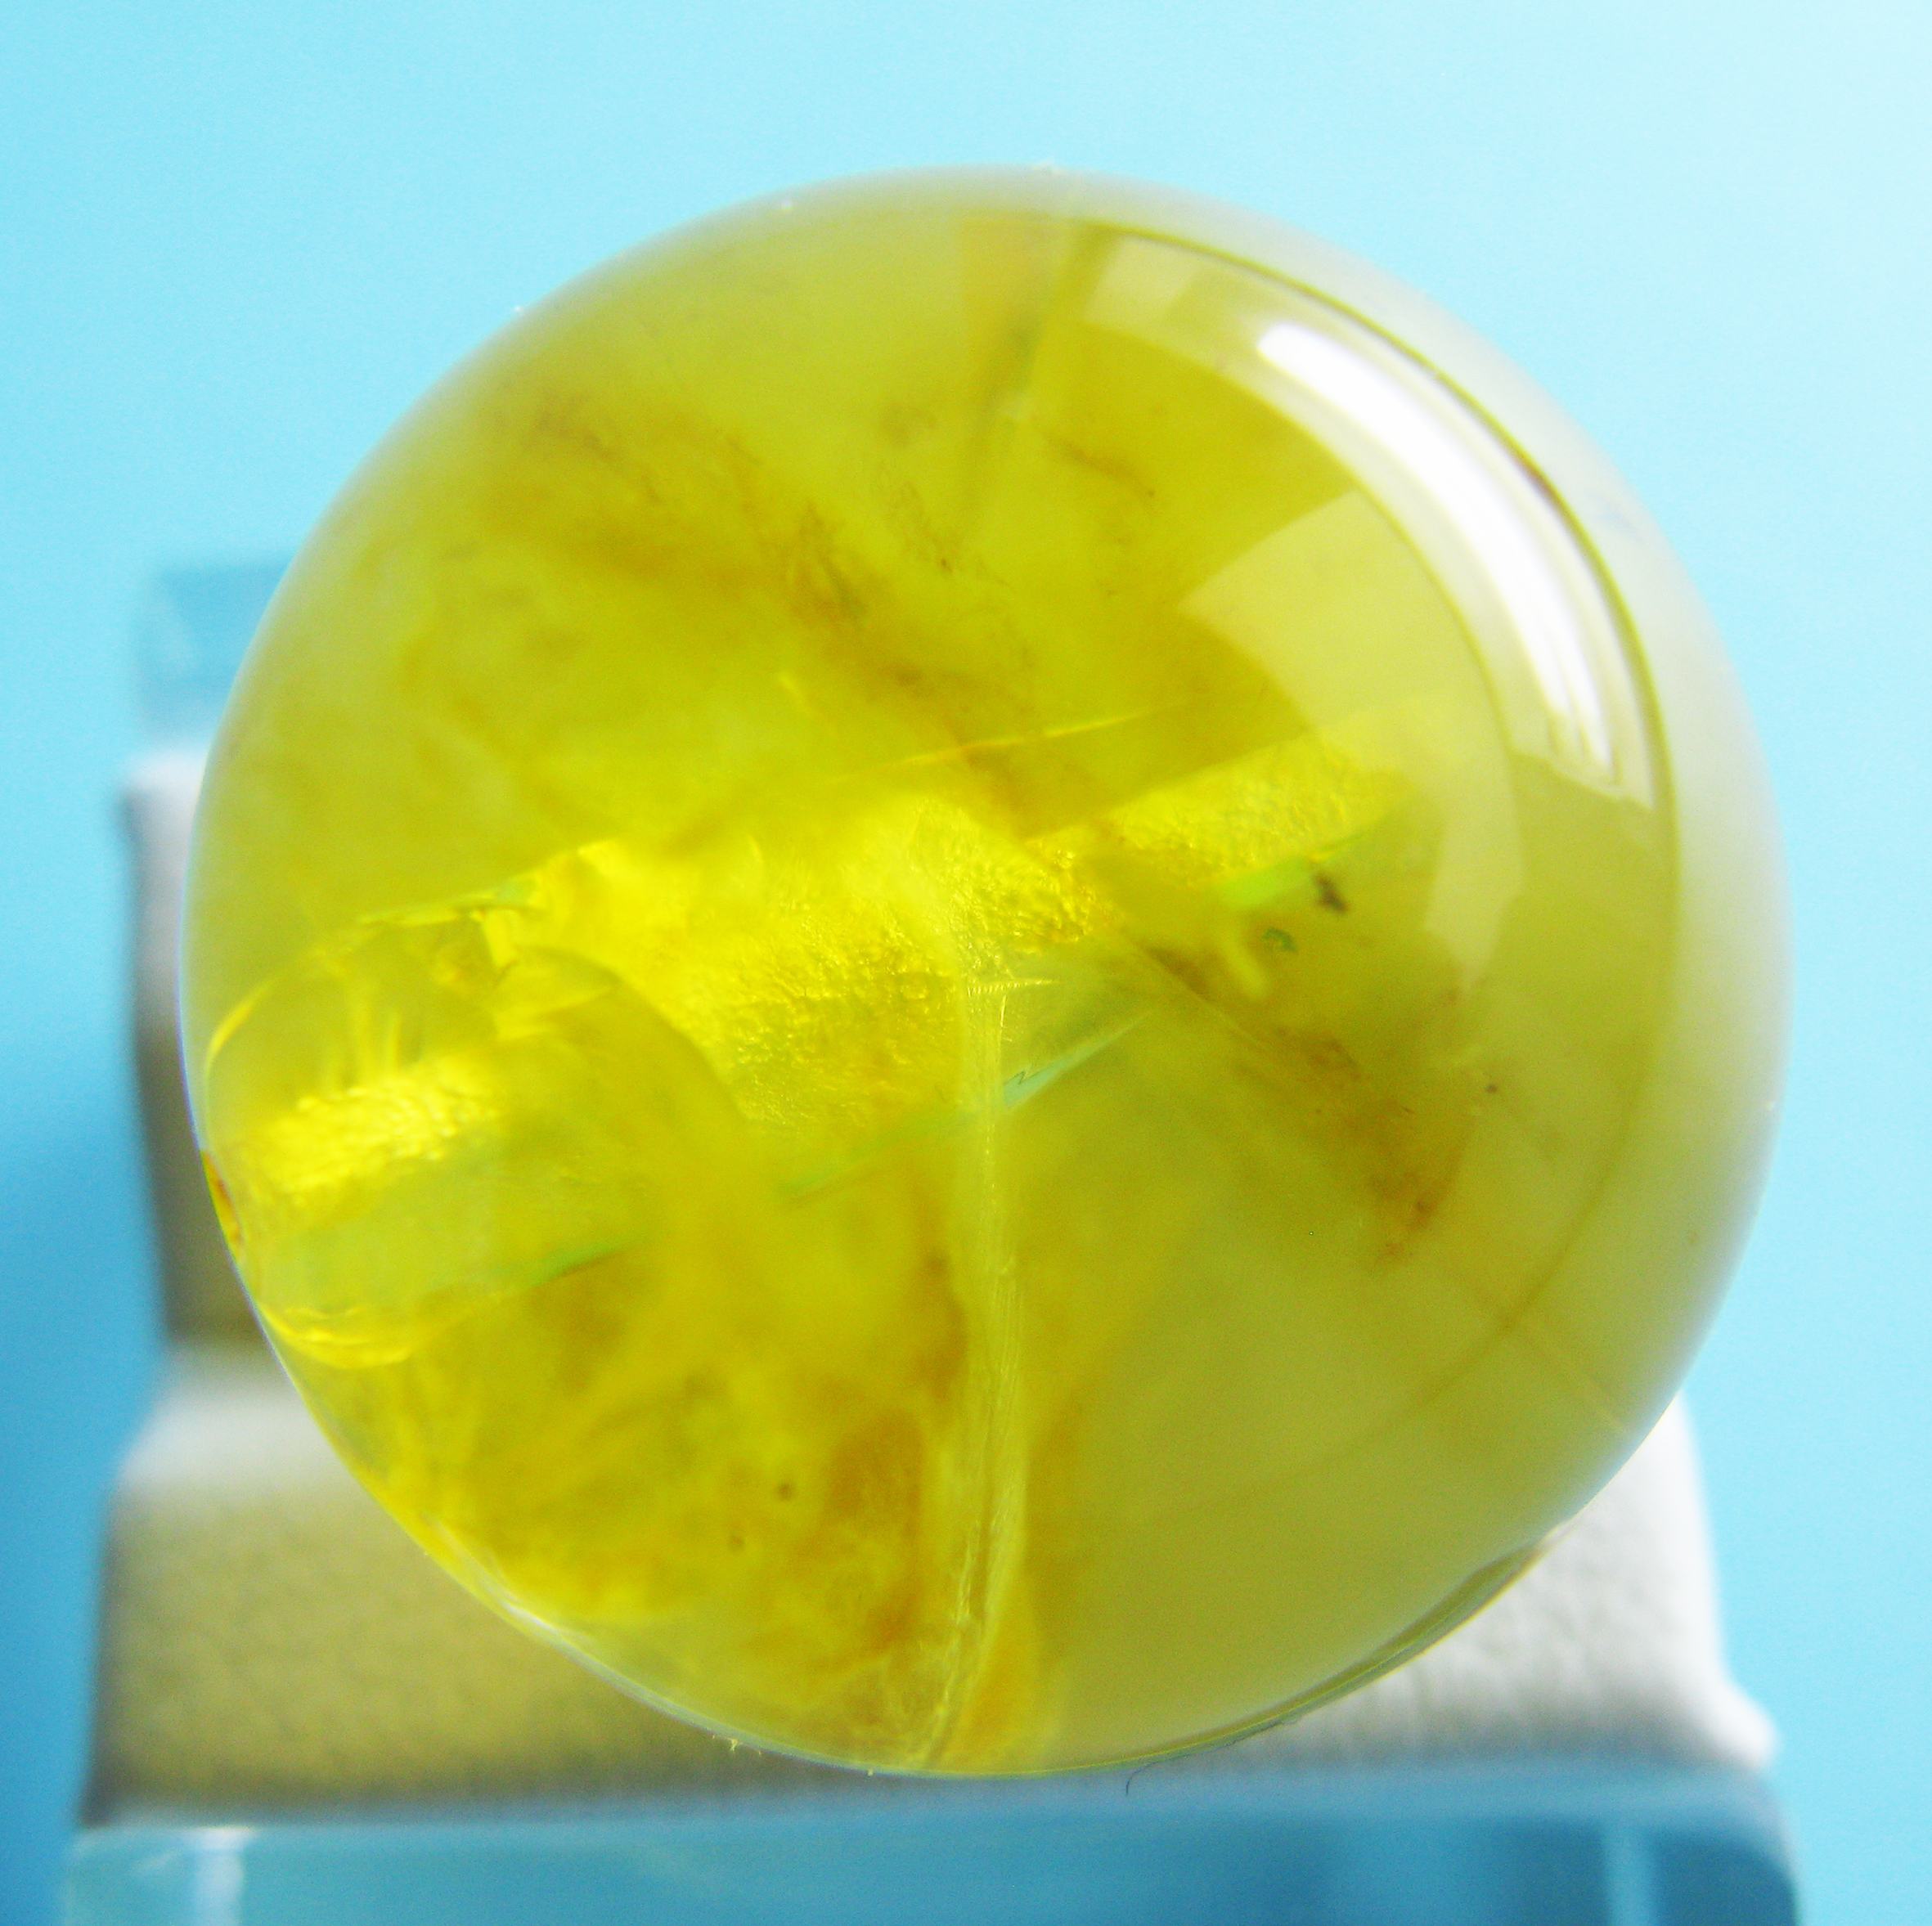  Фото обр. 1. | 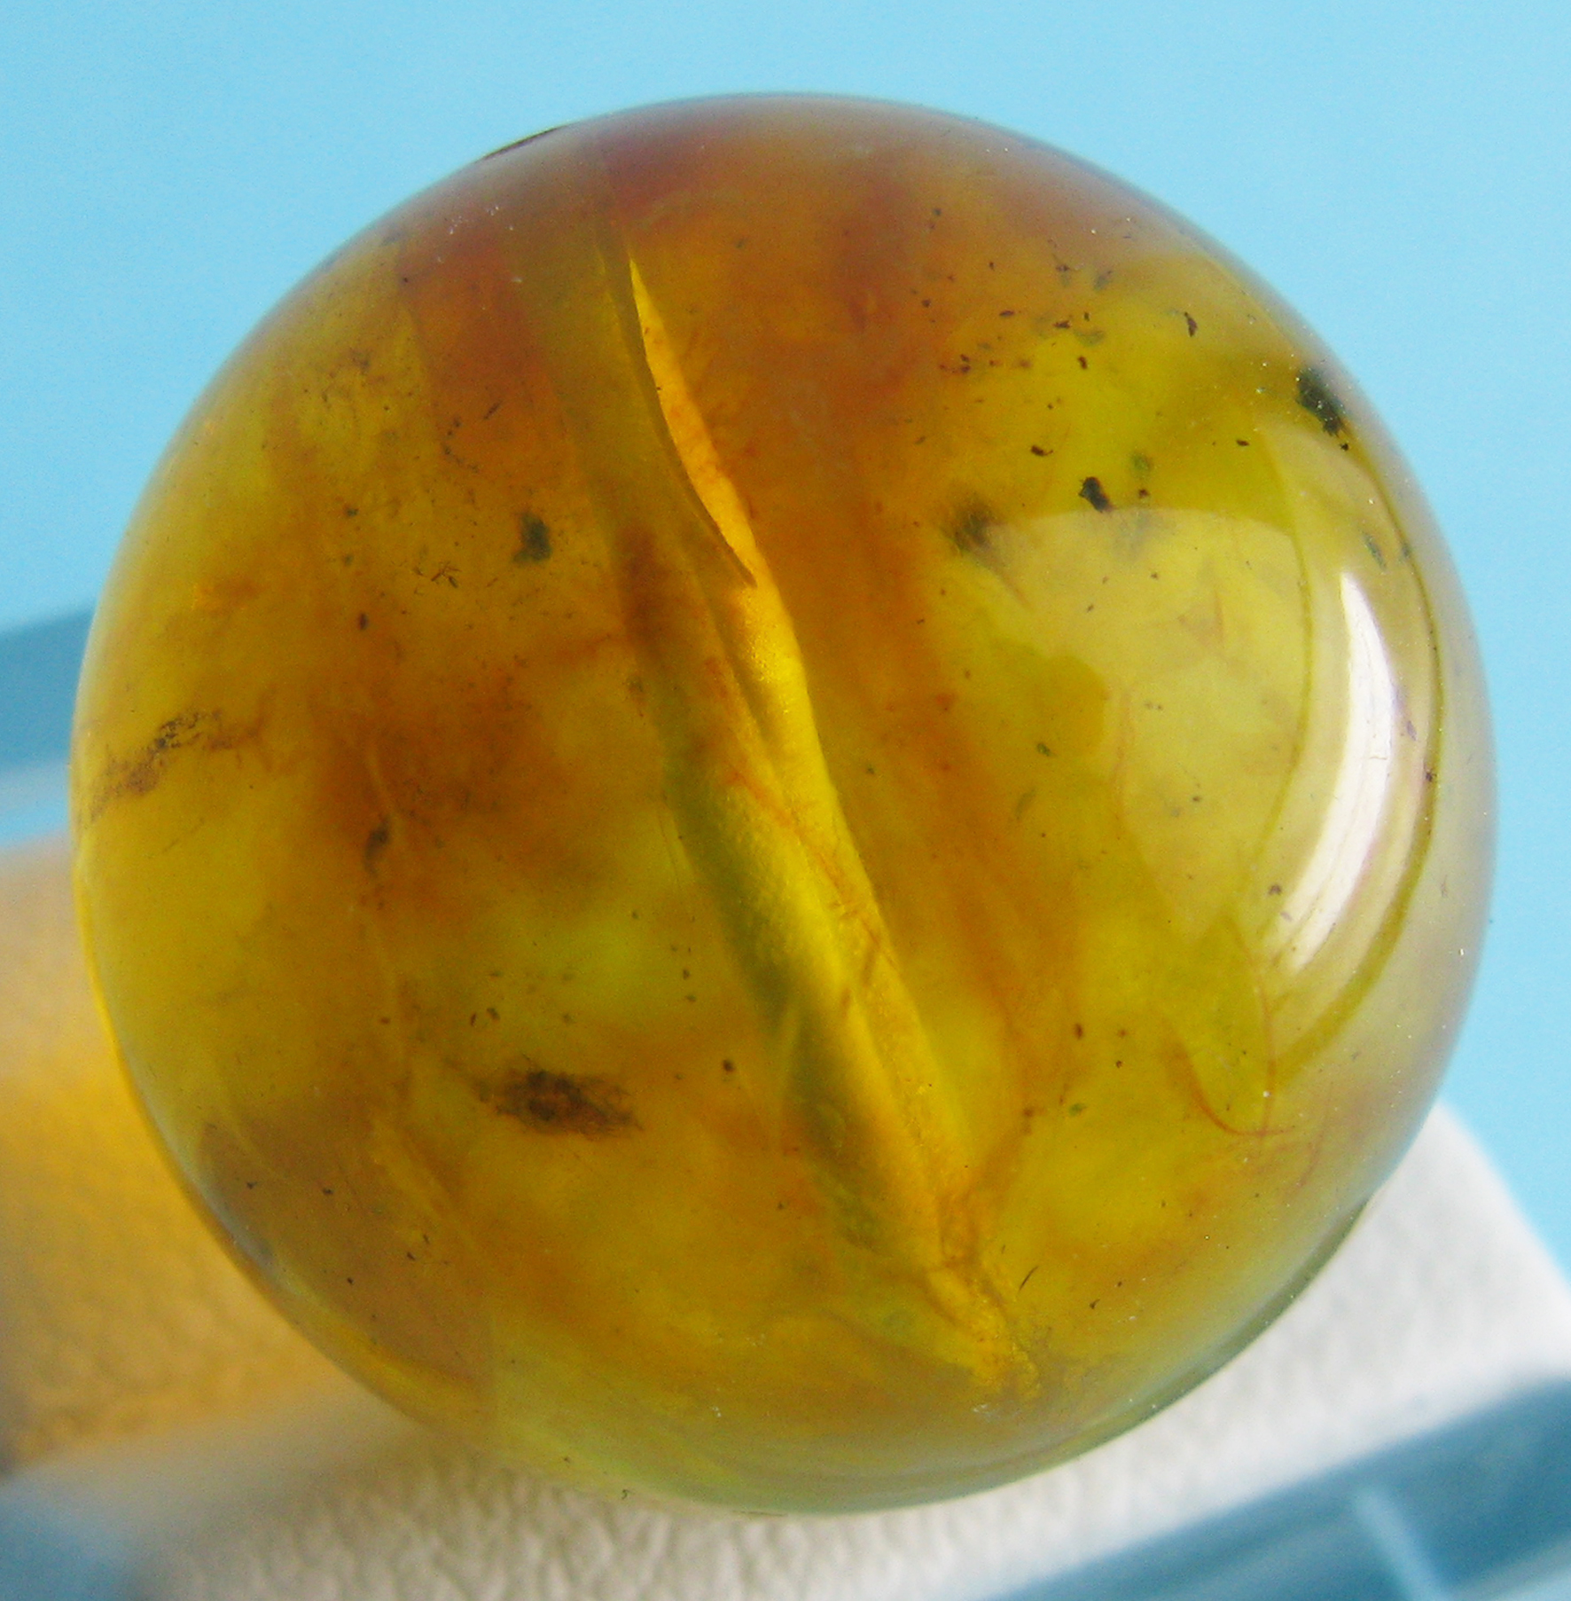  Фото обр. 2. | 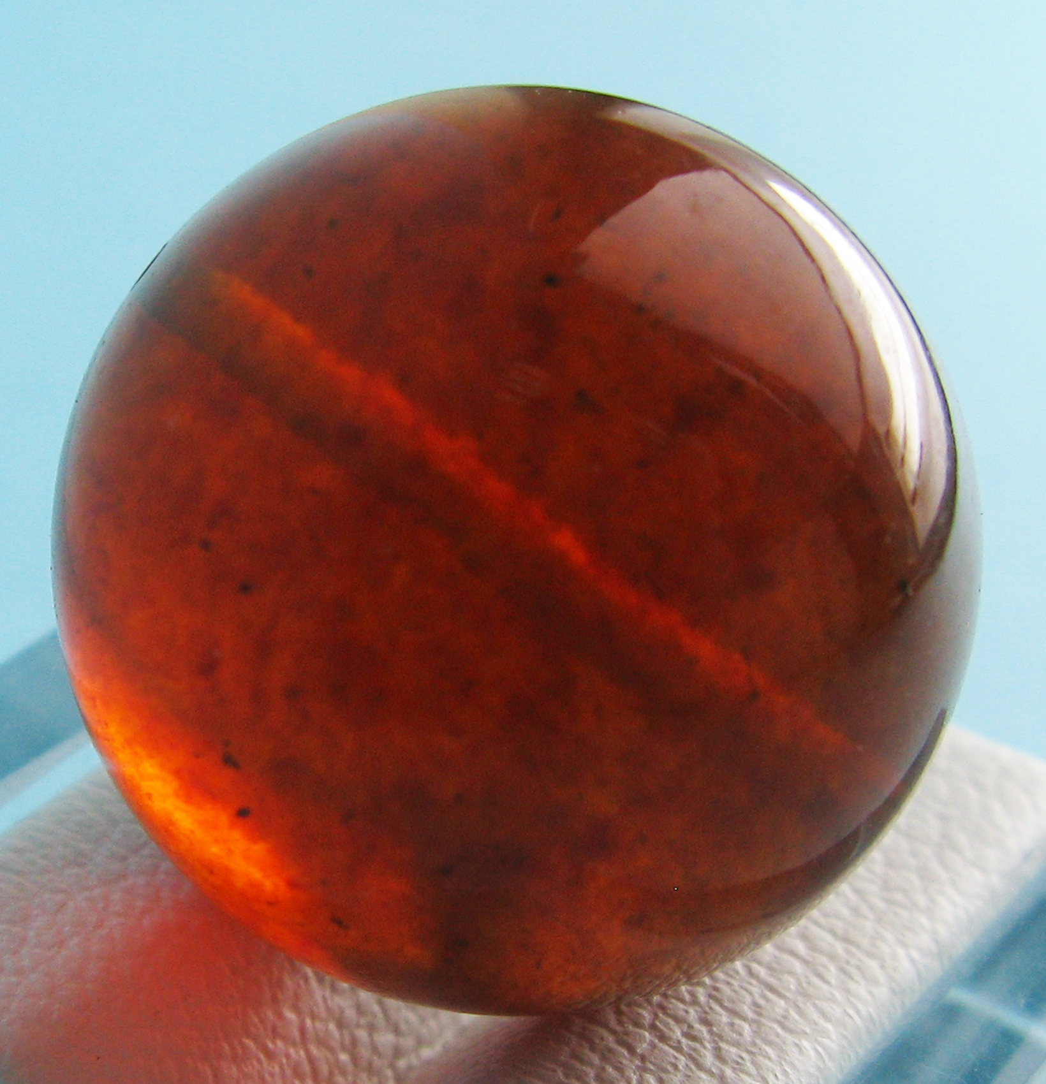  Фото обр. 3. | 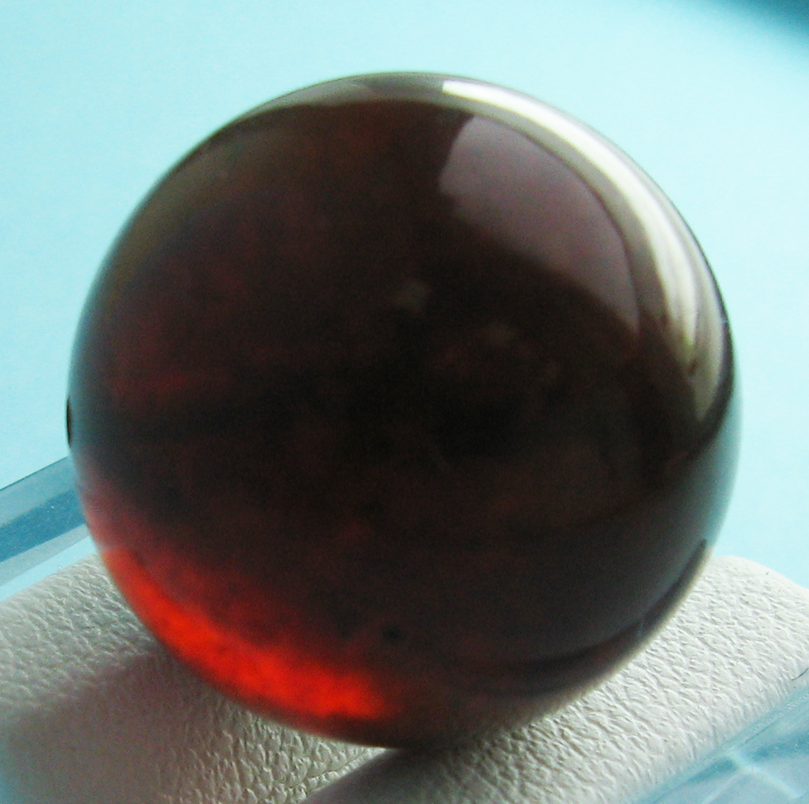  Фото обр. 4. | 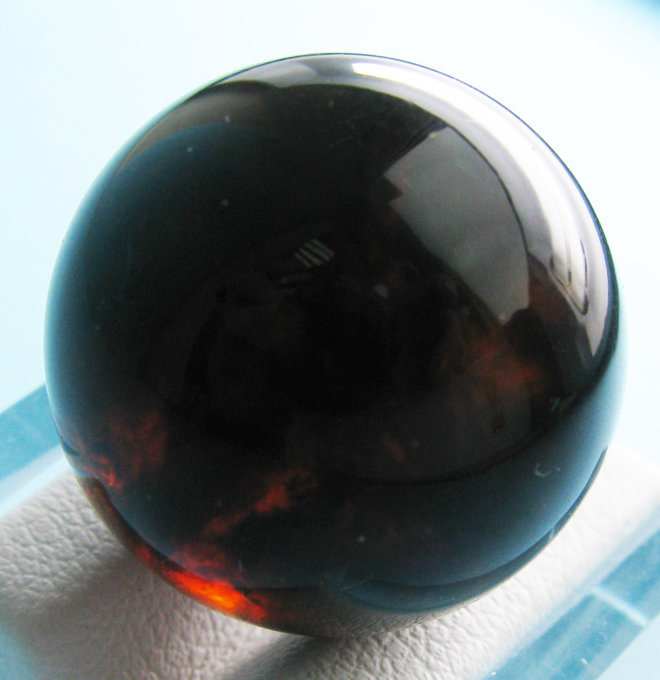  Фото обр. 5. | 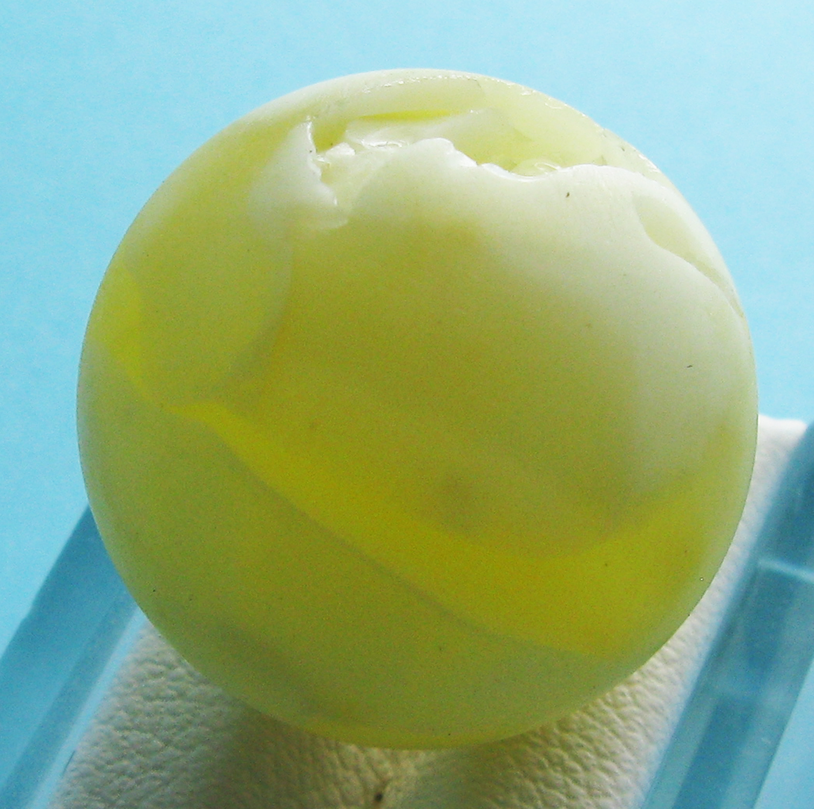  Фото обр. 6.

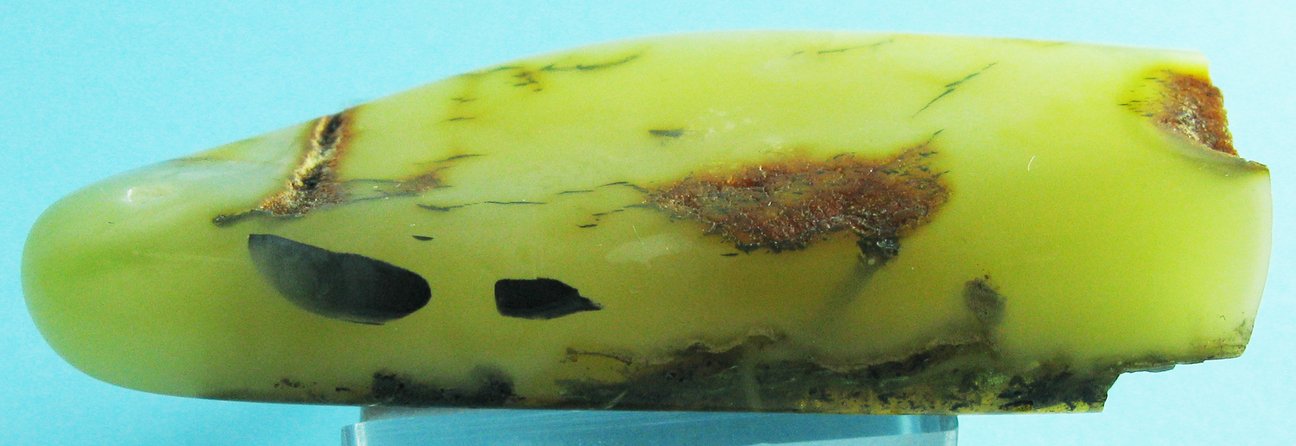

Фото обр. 7.

Pictures 1-7 - materials submitted to the study: 6 beads and one sample of tumbled amber. In accordance with the picture number infra-red spectrum of samples are attached to expertise .
Six (6) round beads made of amber total weight of 24.40 grams (pictures 1-6) and one sample of tumbled amber (picture 7), weighing 6.03 grams, elongated shape, nonuniform color. Beads №№1-3 - transparent, others beads and tumbled amber are translucent polished. high quality processing. The diameter of the beads from 18 to 21 mm, the size of tumbling 40x25x8 mm.
Diagnostics of beads. Though the ultraviolet light (365 nm) and blue- and greenish- white of varying intensity, thermal conductivity tests are correspond to amber. The structure of beads is homogeneous amorphous, in beads №1 and №2 are areas of darker amber (dark yellow and reddish-yellow in beads №№ 3-5 - areas and stains of reddish, brownish, brown, in the bead №6 on a background of translucent white - parts of transparent, characteristic yellow "amber" color, in tumbled amber (sample №7) - areas of dark brown, orange-brown, thin streaks of black can be found.
Following beads characteristics are established (samples 1-6): hardness - 2 - 3 according to Mohs, no cleavage, viscosity, distinctive "gummy" smell when ignited, the density of different beads from 1.05 to 1.30 (Pycnometric method).
Under the microscope, beads and tumbled amber are isotropic refractive index is 1.535-1.556 in different samples and their locations.
For the diagnostics of the material all seven (7) samples (Pictures 1-7) were studied on the multifunction infrared Fourier spectrometer Thermo Scientific Nicolet 6700 (CCU FEGI FEB RAS) with an additional set of add-on devices, the ability of double diaphragming of IR beam, spectrum image registration in transmission and reflection mode. The investigated samples give a specific infrared spectrum (in the 700-1900 cm⁻¹), which allows uniquely distinguish it from other amber-like fossil resins (see. Annex 1). Conclusion: 6 beads and one tumbled amber sample are natural Baltic amber - succinite. Signs of gentrification were not investigated.
To determine the grade of samples submitted for examination classification of Baltic amber, which builds on the differences in color, transparency, and ability to polish was applied:

1 - transparent, typical "amber" color from nearly colorless to dark brown; easy to polish. Gem stone is considered to be of the highest quality if it has lemon yellow color, translucent throughout the all mass;
2 - a translucent, slightly hazy with air bubbles from yellow to dark yellow, rarely red and blue; easy to polish;
3 - an opaque, white; easy to polish;
4 - "bone" - opaque, ivory; may be polished.
5 - layered, with inclusions of insects and other objects; may not be polished.
6 - a frothy, white; may not be polished.
7 - dirty, dark to black; may not be polished.
According to the classification, samples №№ 1-5 are 1-2 grades, samples №№ 6-7, respectively, are 3 and 4 grades.

Conclusion:
6 beads and one tumbled amber sample are natural Baltic amber - succinite. Signs of gentrification were not investigated.

Expert gemologist Head of the laboratory, expert gemologist
V.B. Tishkina V.A. Pakhomov

Seal:
SI Far East geological institute FEB RAS * r.u. Dk 1338
Gemmological laboratory

